The environment: FAQs
CONTACT
GALLERY
PROJECTS
ABOUT US
HOME

What is the greenhouse effect?
When heat is trapped in the earth’s atmosphere it causes the earth’s temperature to rise.
What is the ozone layer?
The ozone layer protects us from the sun’s radiation. Some pollutants are making a hole in the ozone layer.

What can you do?
Before you go to bed, check: has the TV been switched off! Have all the lights, computers and DVD players been turned off?
Use public transport or get a bike!
Plant trees - it’s fun and a great way to control greenhouse gases. Trees absorb carbon dioxide, a greenhouse gas, from the air.

What is global warming?
The rise in temperature, caused by greenhouse gases.
What does all this mean for our future?
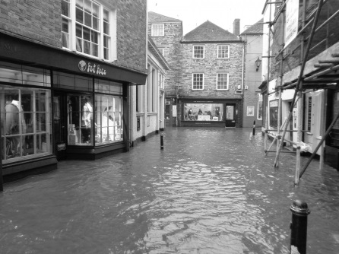
The pessimistic view
In the future, serious floods and drought will be caused by climate change. Sea levels will rise. Water supply and the climate will be affected by deforestation. Air pollution will be made worse. Disease will spread.

What causes the greenhouse effect?
The greenhouse effect is caused by natural activity (e.g. volcanoes) and human activity (e.g. exhaust fumes from cars).
The optimistic view
We can slow down climate change if we plant more forests. Yes, forests are being cut down but new trees are being planted. Coal and oil are being replaced by wind and solar energy.
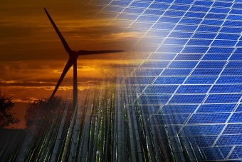
Recycle cans, bottles, plastic bags, and newspapers. When you recycle, you produce less rubbish.
Buy recycled products - these are made from things that have already been used.

