Mood food
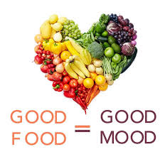
We are often told that „we are what we eat” but seldom do we hear “you feel what you eat”. Research suggests that certain foods affect mood – for better or worse. Not only do dietary changes cause chemical changes within the brain but they also cause changes in our behaviour and emotions. ………… Rarely do we think about the link between what we eat and our mood or our performance at work or school. Here’s a closer look at how your diet could be affecting your mood and school work!
We don’t eat regularly enough
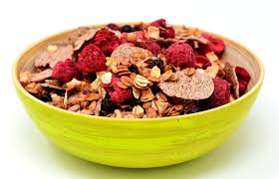
Food is fuel: If you miss a meal, you’ll soon feel tired and run out of energy. ………… Under no circumstances should you go without eating for long periods: your blood sugar levels will drop, which will provoke mood changes (and make you more likely to become ill). Experts advise you to try and aim for a meal or snack every four hours. They also tell us there is no way we should skip breakfast, as it is a particularly important meal – especially in our teens. Research shows it helps students get better results and improve behaviour and concentration. Not only does breakfast make students less likely to be hungry later but it also helps to maintain healthy weight. But remember: not all breakfasts are the same. ……….. . Only after you eat a good breakfast will you be able to keep going all day long at school.
We cut down on carbs
Your body needs carbohydrates to produce serotonin: with the right amount of carbs, not only will you feel more cheerful, but you will have less appetite and feel calmer. Little do low-carb dieters know that because of their diet they are more likely to feel tired, irritable and depressed, than those who get the recommended amount, but some carbs (sweets, cake or biscuits and other sugary choices) bring you down. …………… You should try a diet based on complex carbohydrates such as: pasta, muffins or brown bread. Not only will you feel happier but you will also feel more relaxed.
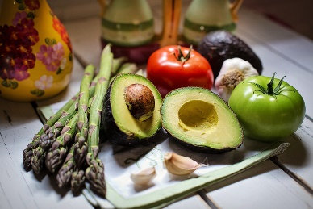
You don’t get enough omega-3-fatty acids
Omega-3s, which are found in oily fish like salmon, mackerel, and sardines, improve both memory and mood. Research suggests that low omega-3 levels are linked to depression, blood pressure, tiredness, and sudden changes of mood. Indeed, depression rates are typically lowest in countries like Japan, where oily fish is a diet staple. …………
We don’t get enough nutrients
Getting too little iron can mean stress, fatigue, inattention and loss of self-confidence. Iron-rich foods include red meat, egg yolks, dried fruit, beans, liver and artichokes.
We eat too much fat
That bag of crisps is not good for your waistline or your mood. Greasy choices – particularly those high in saturated fat, such as bacon, butter and other dairy products – are linked to depression. ………..
EXERCISES:
- Six sentences have been removed from the text. Choose from the sentences A_G the one which fits each gap (……). There is one extra sentence which you do not need to use. Then listen and check.

A: We’re not just talking about a doughnut and coffee: what is recommended is high-fibre cereal with a handful of fruit, or a cup of oatmeal with some milk and berries.

B: Skipping meals is like trying to run a car without petrol.

C: Do you need a quick mood boost, to cheer you up?

D: The last meal of the day should be a couple of hours before you go to bed.

E: So, although there is little evidence that omega 3fatty acids prevent cancer, heart disease or stroke, they are positive in other ways.

F: What’s more, a large, high-fat meal will almost instantly make you feel sluggish.

G: While we know a lot about the link between food and physical health, the effect on how we feel is not as well known.

- Read the article again. Are the following good or bad for you, according to the text? Make a table into your exercise book!

coffee cereal milk cake biscuits pasta sardines bacon cheese
butter

- Put these words and expressions into the correct group. Make a table into your exercise book: Food/Nutrients/Health

root vegetables headache carbohydrates catch a cold pain low in fats feel ill check-up sugary heart-disease rich in vitamins tiredness mackerel sugars
flu allergy weight high level of minerals
doughnut berry stroke full of iron
fatigue liver blood pressure high in protein
dairy products get over sore throat
feel bloated

- Answer the following questions into your exercise book:
  - What is common saying about food, according to the article?
  - How do dietary changes affect you?
  - List the 5 big eating mistakes, according to the article!
  - Why are omega-3 fatty acids so important to your body?
  - What kind of carbohydrates are healthy?
  - Why is a healthy breakfast so important to you?

- Write a text about nutrition and mood food! About 250 words!

