Government and Politics
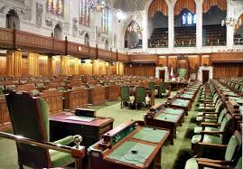
The United Kingdom is a parliamentary democracy. Parliament is made up of (= consists of) the Queen, the House of Lords and the House of Commons. The House of Lords and the House of Commons meet in two separate (getrennte) Chambers in the House of Parliament in Westminster, London.
There is also the Scottish Parliament in Edinburgh, the Northern Ireland Assembly in Belfast and the Welsh Assembly in Cardiff which have control over some aspects of their countries, although the UK Parliament in Westminster is responsible for issues like defence and foreign affairs. These three bodies have Members of Parliament in the UK Parliament.
Elections
There is a general election at least every five years when the Members of Parliament (MPs) are elected. The different political parties present their candidates for election. All UK residents (Einwohner), over the age of 18, can vote for the candidate they want to send to Parliament. The candidate who gets the most votes becomes the MP for the constituency and has a seat in Parliament.
Government
The political party with the largest number of MPs in the House of Commons forms the Government. The Queen asks the leader of this political party to become Prime Minister and to form a government. The new Prime Minister chooses a team of about 100 people from Parliament to run the country with him/her. The most important ministers are called Secretaries of State and they are in charge of (haben die Verantwortung für) a Government Department or Ministry.

The House of Commons
MPs meet in the House of Commons Chamber, where they debate international and national issues and bills (nationale Angelegenheiten und Gesetzesentwürfe). There is a person who controls the debates, called the Speaker, and he/she sits on a raised chair (erhöhter Sessel) at one end of the Chamber. The Government sits on benches on the Speaker's right and the Opposition on the Speaker’s left.
The House of Lords
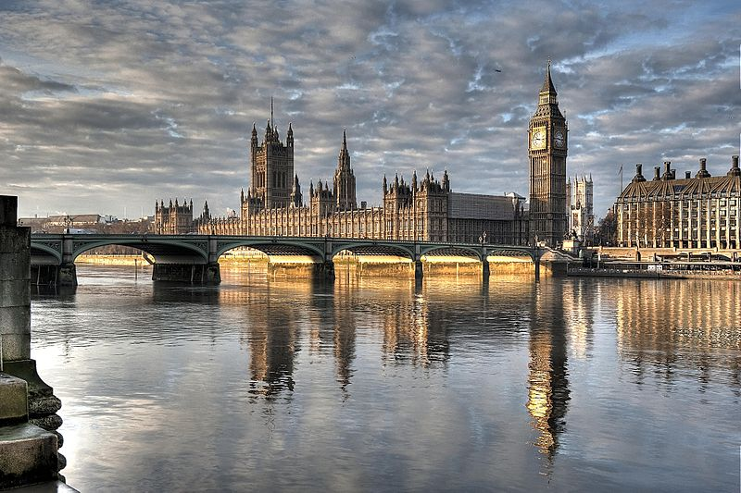
The House of Lords is made up of around 750 members. They are not elected but most of them are recommended by (sind empfohlen von) the Prime Minister and other special commissions, and then appointed (ernannt) by the Queen.

