Answer the following questions in your Exercise book!
Use the texts “British History Timeline” and “Highlights of British History”!

- Who inhabited Great Britain before the Romans? Write about their social life!
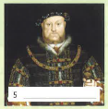
- What do you know about the Romans in Great Britain?
- What happened in the year 1066?
- Why was Henry VIII one of the most famous English kings?
- How did Queen Victoria form Great Britain (Victorian Times, Industrial Revolution)?
